JIM PREPARATORY SCH

NURSERY & PRIMARY

IKI-IKI

“Our God Is Able”

**MID TERM ONE EXAMINATIONS, 2024**

**CLASS : TOP**

**LEARNING AREA 3 : HEALTH HABITS**

NAME: ______________________________________________________

1. **Draw the body parts**.

legs eyes mouth

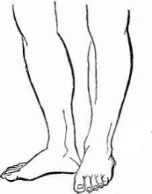

nose ears hands

1. **Name these things we wear.**

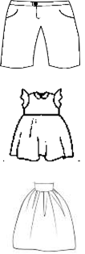





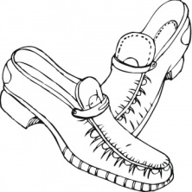

**( skirt , trouser , short , shoes , dress )**

1. **Name our food we eat.**

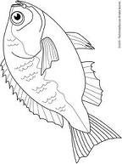



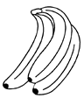

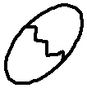

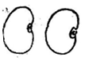

1. **Read and match things we use to clean our body.**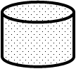

toothbrush

comb

water

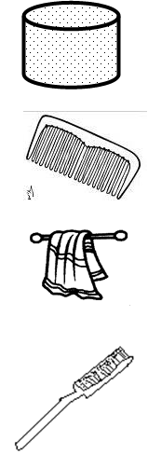

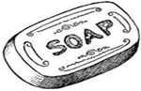



towel

soap



1. **Read and draw our fruits.**

mango ______________ orange _____________

banana _____________ sugarcane ___________

apple ____________

1. **Fill in the missing letters.**

c ____w sh __ ___ p g ___ at d ___ g

p___ g bi___d rabb ____t h____t

1. **Match the same words and draw.**

book yam ________________

door pencil ______________

chair book ______________

pencil door ________________

yam chair ________________

1. **Draw a pineapple and colour.**

***“Good Luck”***